**DAILY ONLINE ACTIVITIES SUMMARY**

|  |  |  |  |  |  |  |  |  |
| --- | --- | --- | --- | --- | --- | --- | --- | --- |
| **Date:** | **21/06/2020** | | | | | **Name:** | **V ANJANA PAI** | |
| **Sem & Sec** | **IV sem & B section** | | | | | **USN:** | **4AL18CS094** | |
| **Online Test Summary** | | | | | | | | |
| **Subject** | | **--** | | | | | | |
| **Max. Marks** | | **30** | | **Score** | | | **--** | |
| **Certification Course Summary** | | | | | | | | |
| **Course** | **Introduction to Information Security** | | | | | | | |
| **Certificate Provider** | | | **Greatlearning academy** | | **Duration** | | | **5.5 hours** |
| **Coding Challenges** | | | | | | | | |
| **Problem Statement: --------** | | | | | | | | |
| **Status: Executed** | | | | | | | | |
| **Uploaded the report in Github** | | | | | **YES** | | | |
| **If yes Repository name** | | | | | **lockdown-coding** | | | |
| **Uploaded the report in slack** | | | | | **YES** | | | |

Online Test Summary: No internals conducted today.

Online Certification Course Summary: Today I completed the Introduction to Information Security course by taking up the quiz and obtained the certificate for completion of course.

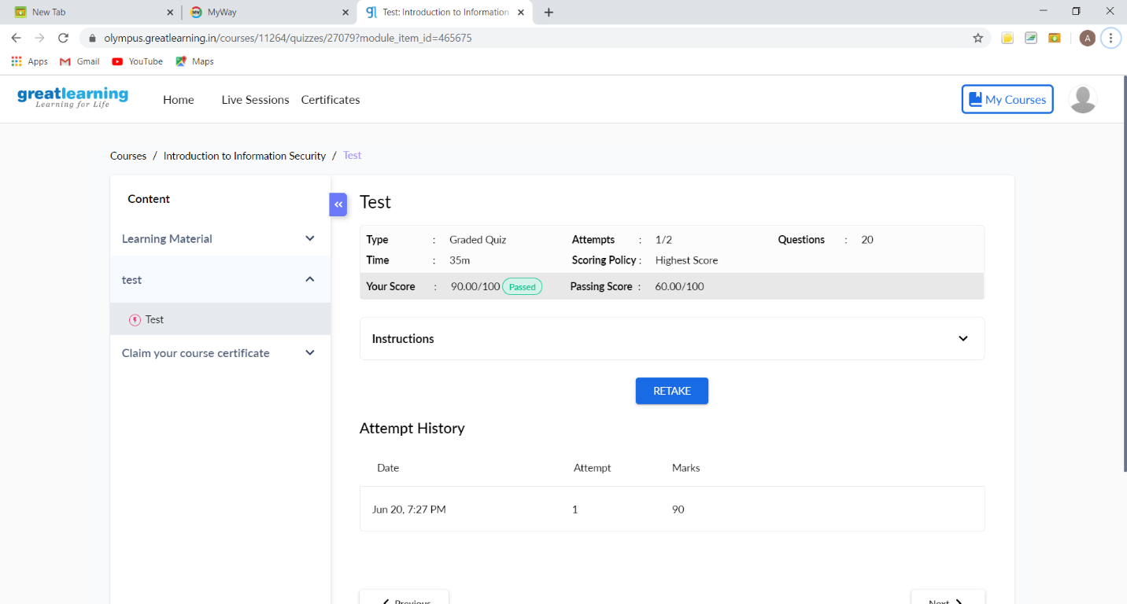

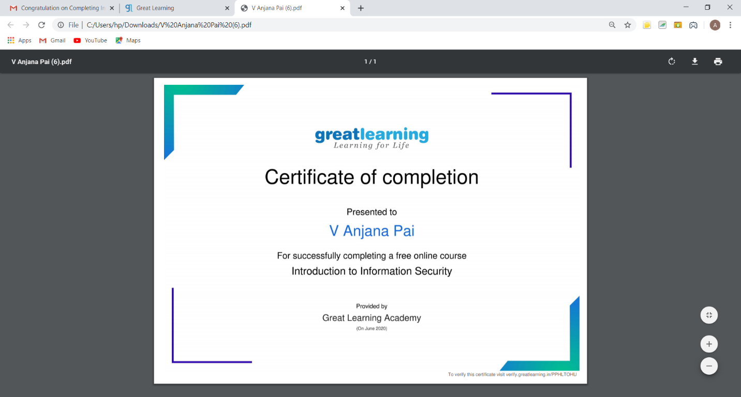

This is the certificate obtained after completion of the course.

Online Coding Summary: **No programs given today.**